**Defect Report**

**Defect 1**

**Defect Summary:**

Missing “Forgot Password” functionality.

**Steps to Reproduce:**

1. Launch the site and verify the header

**Expected Result:**

“Forgot Password” link should be displayed.

**Actual Result:**

“Forgot Password” link is missing.



**Defect 2**

**Summary:**

‘Model’ filter on popular make page doesn’t work properly.

**Steps to Reproduce:**

1. On the main landing page, click on “Popular Make” category
2. Click on filter: ‘Model’

**Expected Result:**

Car model names should arrange in alphabetical order.

**Actual Result:**

Default sorting by rank remains.Model alphabetical sorting doesn’t work, nothing happens when ‘Model’ is clicked.

**Screenshot:**

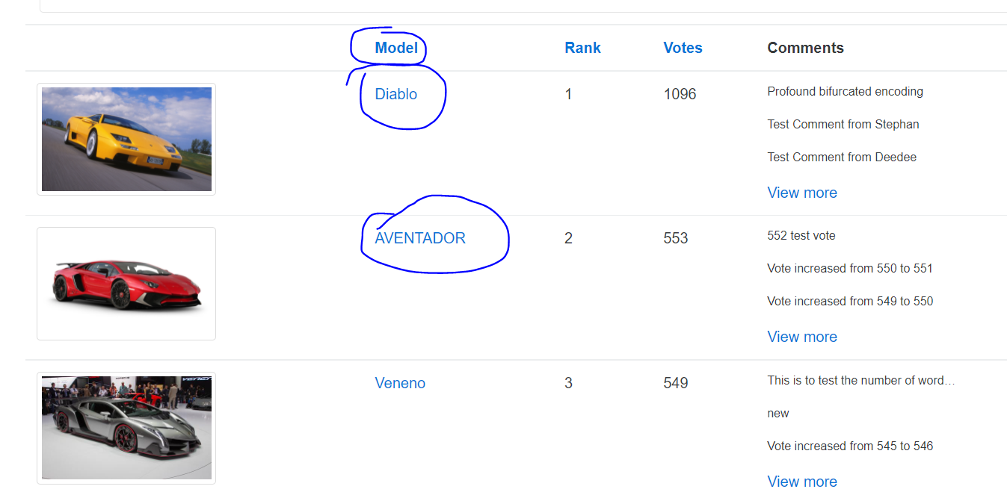

**Defect 3**

**Summary:**

Broken navigation link on Popular Make page

**Steps to Reproduce:**

1. On the main landing page, click on “Popular Make” category
2. Click on ‘Buggy Rating’ link at the top left corner of the page to go back to Main Page display

**Expected Result:**

Navigate back to the Main Page display

**Actual Result:**

Nothing happens, when you hover on the Buggy Rating link a url is displayed on the lower left corner -> https://buggy.justtestit.org/broken

**Screenshot:**

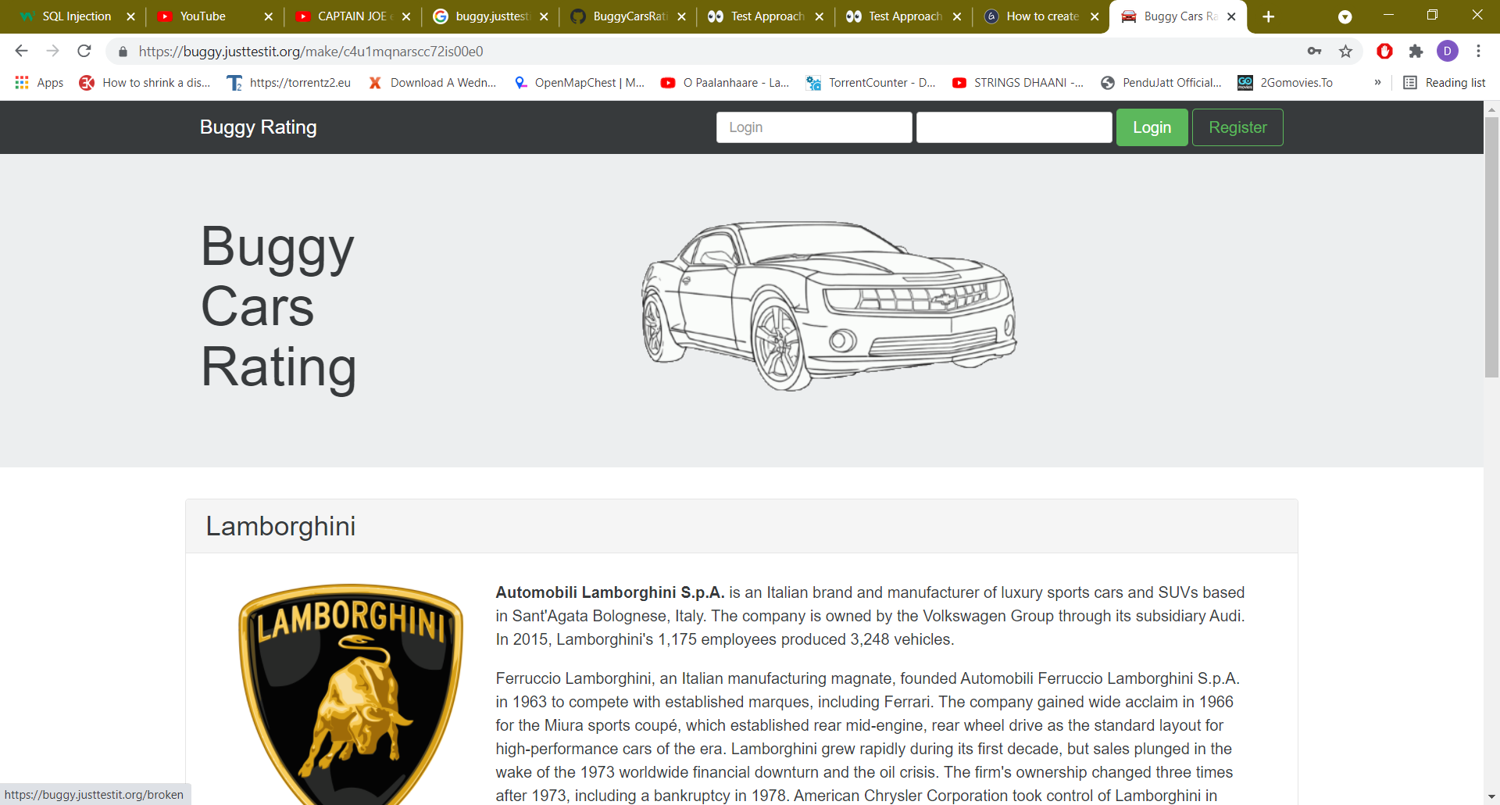

**Defect 4**

**Summary:**

Pagination issue on ‘Overall Rating’ page

**Steps to Reproduce:**

1. On the main landing page, click Overall Rating Image link to navigate to Overall list page
2. Navigate to the last page as per the displayed list (Page 5).

**Expected Result:**

On the final page, next page link should be disabled.

**Actual Result:**

Next page link is enabled and page number increases on every click. Ideally, max pages available should be greater than or equal to current page selected.

**Screenshot:**

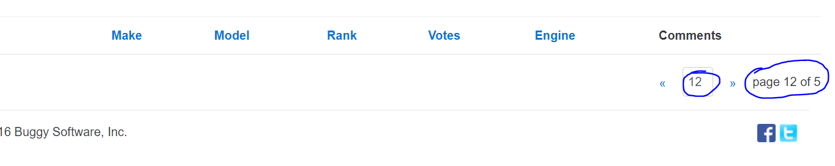

**Defect 5**

**Summary:**

Image link broken for Lancia Ypsilon.

**Steps to Reproduce:**

1. Navigate to Lancia Ypsilon page using this url: https://buggy.justtestit.org/model/c4u1mqnarscc72is013g%7Cc4u1mqnarscc72is0150

**Expected Result:**

Car make and model images should be displayed properly.

**Actual Result:**

The link to the image of the car ‘Lancia Ypsilon’ is broken

**Screenshot:**

